IPH Limited (ASX: IPH)
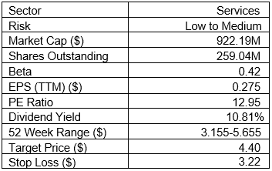
Company Profile:
IPH Limited is an Australia-based company, which provides intellectual property (IP) services. The Company provides services for the protection, commercialization, enforcement and management of all forms of IP, including patents, trademarks and designs. It operates through three segments: Australian and New Zealand IP, Canada IP and Asia IP. The segments offer services related to the provision of filing, prosecution, enforcement and management of patents, designs, trademarks and other IP services. The Company has a network of member firms servicing approximately 26 IP jurisdictions. The group includes IP firms AJ Park, Applied Marks, Griffith Hack, Pizzeys, ROBIC, Smart & Biggar, Spruson & Ferguson, and online trademark provider Applied Marks. It works with a diverse client base of Fortune Global 500 companies and other multinationals, public sector research organizations, small and medium-sized enterprises (SMEs), and professional service firms.

Stock Performance Profile:
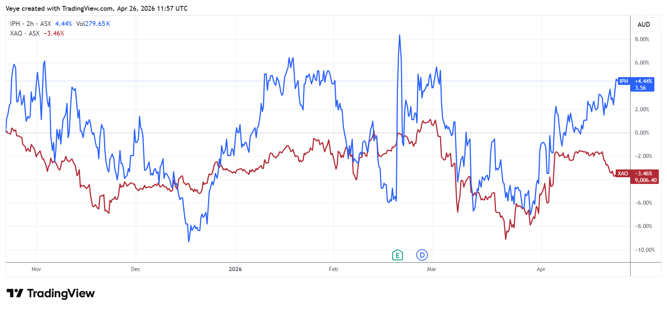
(Chart Source: TradingView) Six-month Performance of IPH compared with XAO. IPH delivered returns of 4.4% in comparison of -3.46% by XAO over this period.

From the Company Reports:
IPH Limited (ASX: IPH), on 19 February 2026, announced its HY26 results which was led by a strong turnaround in Canada and a return to growth across Asia. Management said higher scale and broader geographic diversification have made the business stronger with 58% of underlying EBITDA now generated outside the Australia and New Zealand. The company also distributed an interim dividend of 19 cents per share which was up 11.8% year-on-year.
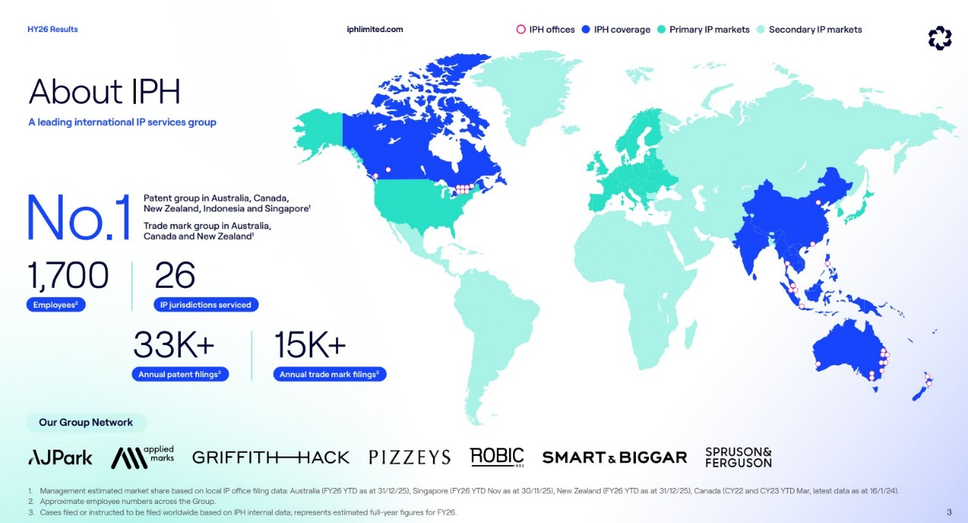
(Graphic Source: Company Report)
Key developments in the period included further integration gains from the Bereskin & Parr acquisition in Canada where IPH has built a market-leading position and now earns more than one-third of group underlying EBITDA from that region. In Asia, the company reported better traction outside Singapore as patent filings excluding Singapore rose 7.3% while four countries recorded double-digit growth led by Hong Kong.
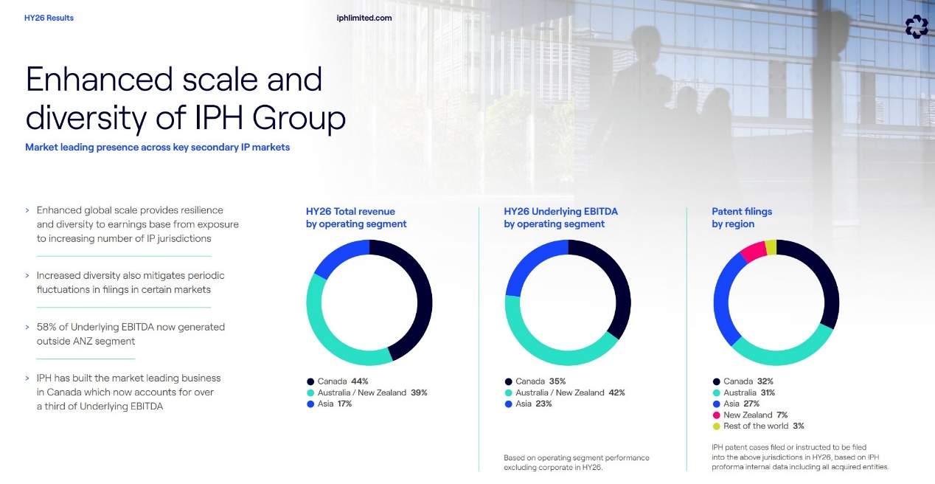
(Graphic Source: Company Report)
Management also refinanced $210 million of loan facilities through to December 2028 at better pricing. It also launched a new on-market buy-back program for up to 12.2 million shares from March 2026. IPH has around 1,700 employees while servicing 26 IP jurisdictions and handling an estimated 33,000+ annual patent filings alongside 15,000+ trade mark filings.

Financial:
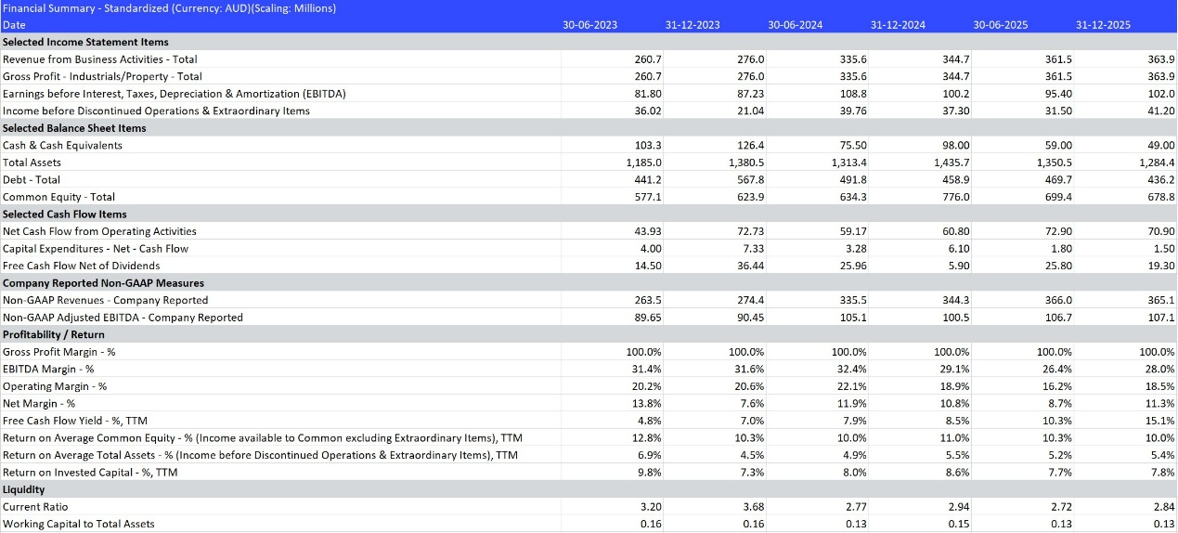

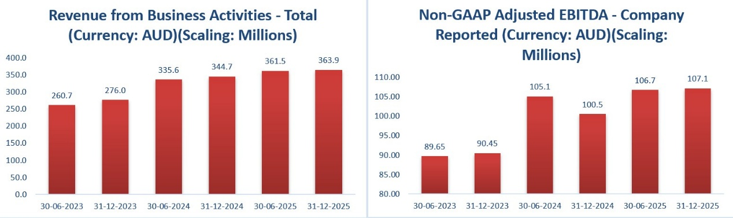
(Data Source: Refinitiv, Thomson Reuters, Graphic Source: Company Reports, Veye Research)
IPH’s financial trajectory has been very impressive as Revenue from business activities rose from $260.7 million in June 2023 to $363.9 million by December 2025 which is helped by acquisition benefits, market expansion and resilient client demand for intellectual property services. Adjusted EBITDA moved higher from $89.65 million to $107.1 million over the same period. The company has continued to generate solid EBITDA margins near the high-20% range which is attractive for a professional services business. Operating cash flow also increased from $43.9 million to $70.9 million while capital expenditure remained low. Overall, the numbers suggest IPH is compounding into a larger and more efficient business with room to reward shareholders.

Financial Forecasting:
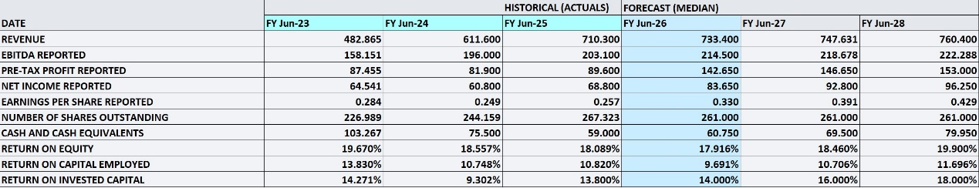
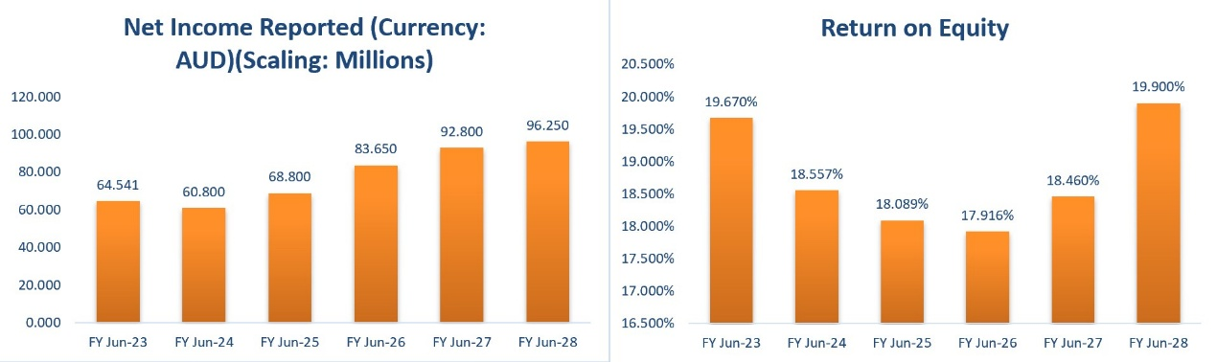(Data Source: Refinitiv, Thomson Reuters, Graphic Source: Company Reports, Veye Research)
IPH’s forward financial outlook is positive with forecasts suggesting the company could grow earnings as well as returns on capital. Revenue is projected to rise to $747.6 million in FY27 and $760.4 million in FY28 which points to steady top-line momentum supported by Canada integration benefits, growth in Asian filings and better operating conditions across key markets. Net income is expected to increase to $92.8 million in FY27 and $96.25 million in FY28 and this suggests margins may improve with the help of technology adoption and scale benefits. Return on equity is estimated to improve from 17.9% in FY26 to 18.46% in FY27 and 19.9% in FY28 which is a strong sign that capital will be used productively.

Distribution Profile:
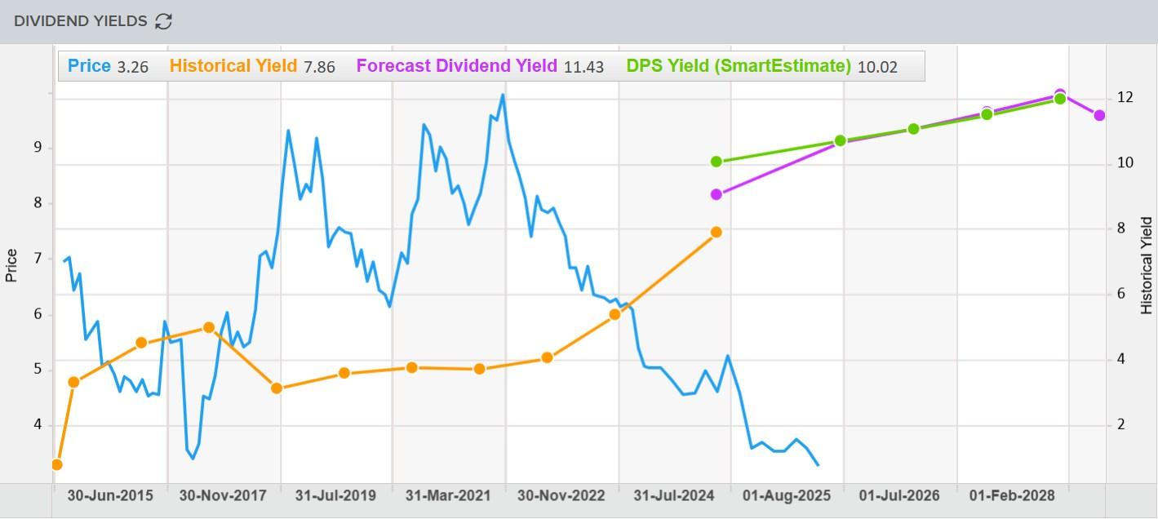
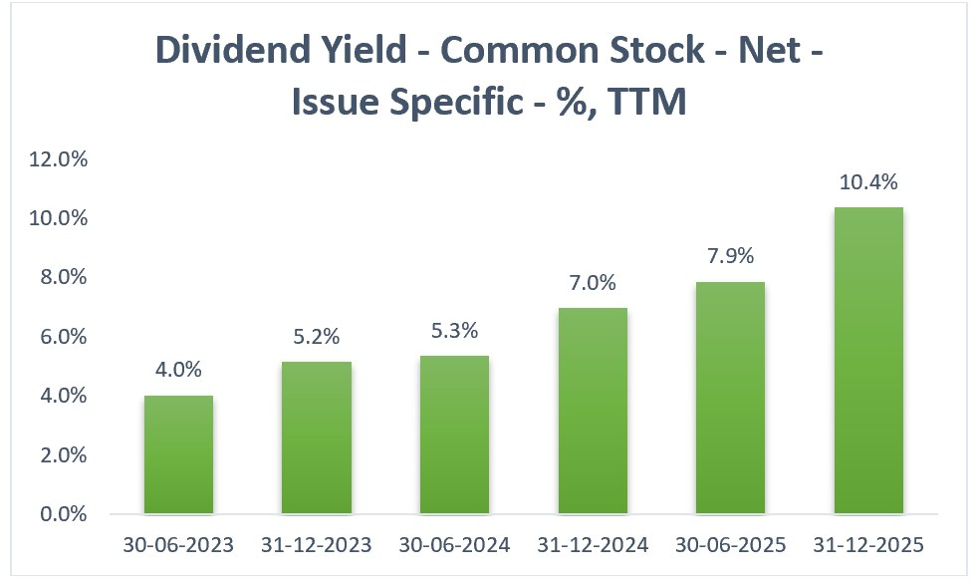
(Data Source: Refinitiv, Thomson Reuters, Graphic Source: Company Reports, Veye Research)
IPH has a very good dividend profile as it has consistently distributed partially franked dividends on a semi-annual basis which shows management’s commitment to returning capital to shareholders. Over the past decade, the payout has almost doubled backed by steady earnings growth and disciplined capital management. The current annual dividend yield is 10.81% which puts it among the best passive income opportunities on the ASX. Forward estimates also indicate the dividend yield will stay in a healthy range of around 10% in the next 2 years.

Industry Analysis:
The intellectual property services industry is generally a defensive and steadily growing sector because companies need patents, trademarks and legal protection regardless of economic cycles. Demand comes from innovation across technology, pharmaceuticals, AI, semiconductors, consumer brands and cross border trade since new products often need filings in multiple countries. Growth estimates for the industry vary by segment but broader IP services growth is expected at about 7-11% CAGR. For IPH, this creates a favourable environment and the growing complexity of global filings support steady revenue opportunities although volumes can fluctuate by country and economic conditions.

Risk Analysis:
IPH is exposed to filing volume cycles across major jurisdictions. This is most visible in ANZ where weakness in US-originating PCT applications has weighed on revenue because the group has relatively high exposure to US clients. Competitive pressure and changing client filing patterns in Singapore and other markets may also affect market share. Labour cost inflation may pressure margins and foreign exchange movements also remain important as around 34% of annualised revenue is generated in US dollars.

Outlook:
IPH’s strategy for now is focused on organic growth and in Canada, management expects more benefits from its market-leading integrated platform. In Asia, the company aims to benefit from higher filing activity by targeting international corporate clients and case transfers. Business development efforts in ANZ have been redirected toward Western Europe, Japan, South Korea and Chinese inbound filings. IPH also plans deeper use of AI in core operations to streamline workflow, lower costs and improve client service. Management noted filing performance has improved since the AGM.

Technical Analysis:
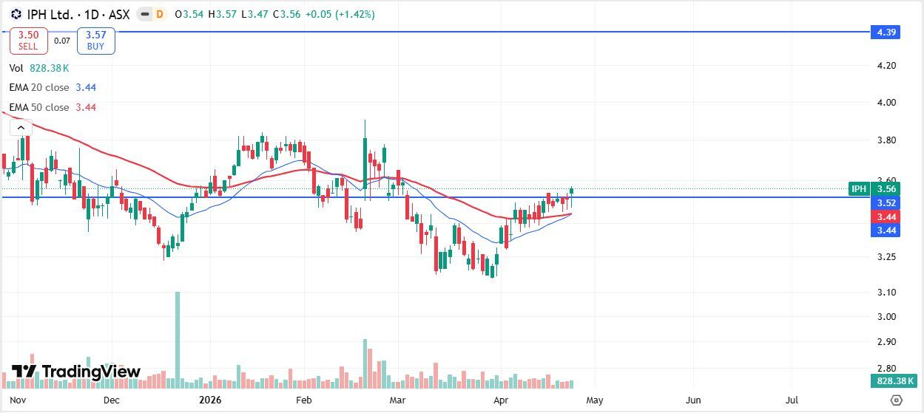
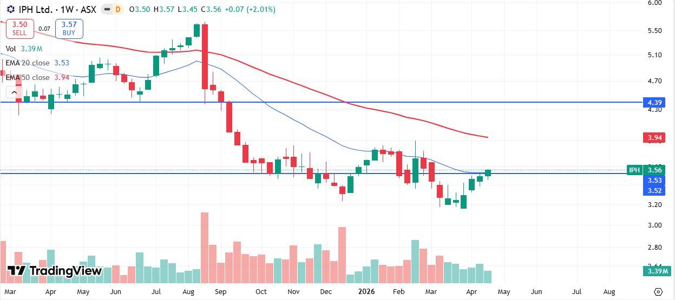
(Chart source: TradingView) Daily and Weekly Candlestick Price Chart Pattern
IPH is showing a constructive recovery with price climbing above both the 20 and 50 EMAs (Exponential Moving Average). The recent series of higher lows and stronger bullish candles suggests improving momentum and growing buyer confidence after the previous correction. A sustained breakout above this level could trigger further upside toward the next major resistance keeping the short- term outlook positive and supportive of trend continuation.
On the weekly chart, IPH is showing constructive follow through to the daily strength with price reclaiming and holding above the key support zone while improving from recent lows. The stock is now trading around the 20-week EMA suggesting momentum is shifting positively after a prolonged correction and sustained closes above this level could open the path toward the dynamic resistance zone near 50 EMA.

Veye’s Take:
IPH is a high-quality and relatively defensive ASX business with strong positions across intellectual property services and also has broad geographic exposure. The company also benefits from operational efficiencies, shareholder friendly capital returns and long-term demand linked to global innovation. The valuation looks reasonable as the forward price/cashflow ratio is 6.35 versus the industry median of 7.42 while the price/book ratio of 1.34 is modest for a relatively capital light business. Liquidity is comfortable as the current ratio has remained consistently between 2 and 3 in recent years. Overall, IPH is a good pick, especially for dividend focused investors who seek passive income at sensible valuation along with long- term growth potential. Veye recommends a “Buy” on “IPH Limited” at the closing price of $3.56 (As of 24 April 2026).
*All Data has been sourced from Company announcements and Refinitiv, Thomson Reuters

